My Hospital Passport

RED  Things you must know about me | AMBER  Things that are really important to me | GREEN  Things I like and dislike

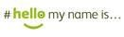

Hello, my name is
:

Photograph of your child

(
)
optional

This gives hospital staff important information about you.

Please take it with you if you have to go into hospital.

RED

Things you must know about me.

Name:
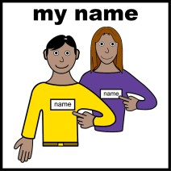
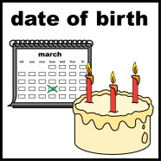  Date of Birth: | 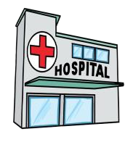  Hospital Number:
Address:  Telephone Numbers: | 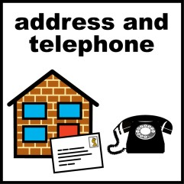
Parent/Carers Names: | Family/people who are important to me  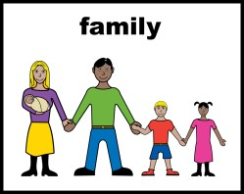
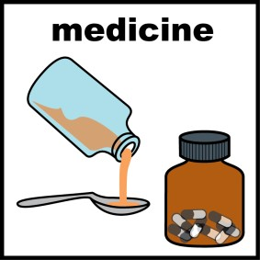

Brief Medical History

Allergies:

Current medication:

How to Communicate with me.

Preferred language (including Makaton, PECS, BSL, non-verbal etc)

AMBER
Things that are really important to me.

Seeing/hearing: (Include visual conditions, glasses, sensitivity to light/ hearing problems,  sensitivity to sound)  Does your child like sensory play in hospital? | 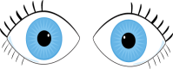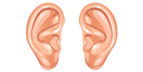
Eating and drinking:  (include likes  &dislikes/support  needed/temperature  /texture) | 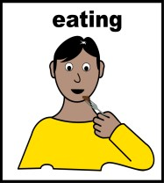
Going to the toilet:  (Am I independent? Do I  need nappies/pads) | 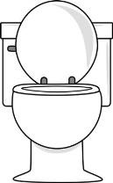
Taking medication:

AMBER
Things that are really important to me.

Moving around:  (Include wheelchair and cushions, hoist, safety  needs) |  | 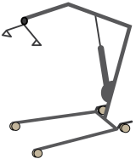
Sleeping |  | 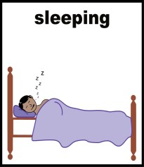
Hygiene and personal care
(include details about words you use when talking to me about my body)

Dressing  (include any support I  need) | 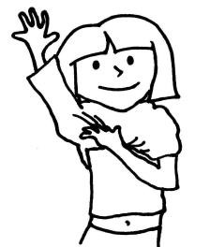
How to express how I am feeling | 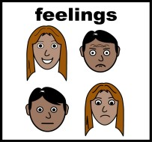

GREEN
Things I like and dislike.

THINGS I LIKE  Please do this: | ☺ | THINGS I DON’T LIKE  Don’t do this: | ☹
Think about – what upsets you, what makes you happy, things you like to do i.e. watching TV, reading, music. How you want people to talk to you (don’t shout). Food likes, dislikes, physical touch/restraint, special needs, routines, things that keep you safe.
☺ |  | ☹

Completed By:
Relations hip to child:

Date:

Adapted from an original form designed by: Kevin Elliot, Health Facilitator,
Gloucestershire Partnership Adapted from an original NHS Trust

